# **Steps to move a Power List Form App from one list to another.**

## Overview

The general plan of moving a Power App to a new list will be as follows:

1. Save the current list as a list template
2. Provision a new list using the list template from step 1, as this will set the Item ID back to 1.
3. Export the Power App form as a “Create As New” package
4. Edit some JSON in the package for the purpose of pointing the form to the new list, and re package.
5. Import the new package in Power Apps
6. Publish the form to the new list

We should save both the List Template and the original Power App Form package in the Custom Artifacts library for the site.

## Detail Steps

1. Go to the List Settings and Save the list as a Template

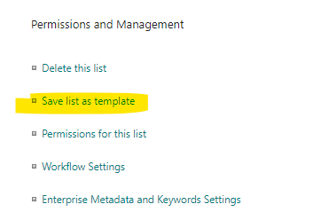

1. Provide a file name and template name. Do not check Include Content

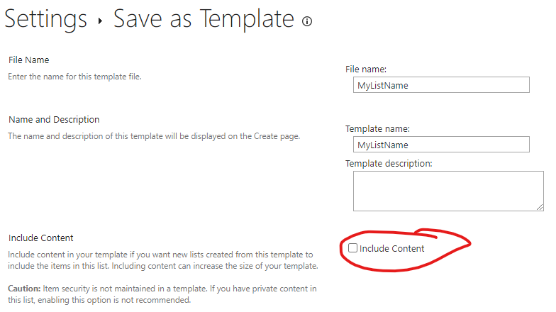

1. Select the Gear then select Add an App

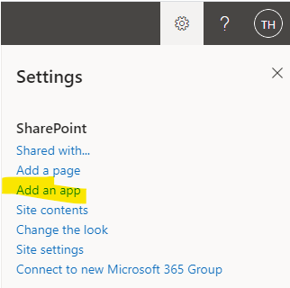

1. Scroll to the end and select your List

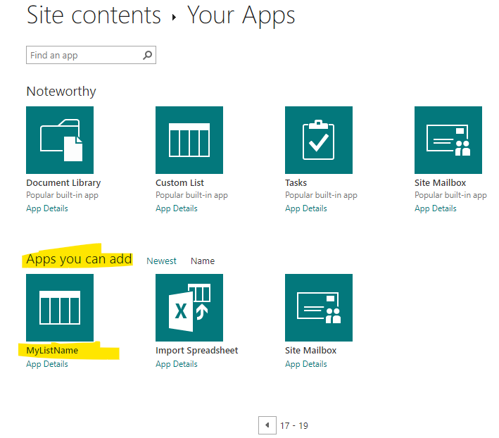

1. Provide a Name and select Create
2. Get the new target ListId by going to Site Content and List Settings, and extracting the ID from the URL. You may need to drop the leading %7B and trailing %7D.



1. Go to the source list, and open the Power App form. Select File, See all versions. Select Export package.

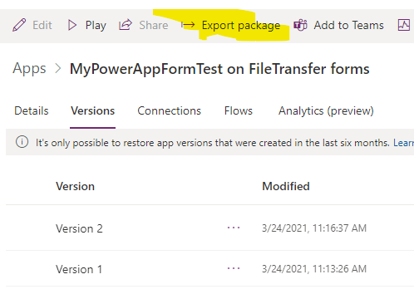

1. Export the Power App, give it a new name <siteNumber> - <siteName>, set the target environment, and be sure to select the Action of Create as new.

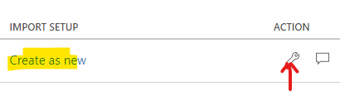

1. Package the Power App and download the zip file. Unzip the file.
2. Rename the root folder to site and application name format: <sitenumber>-<sitename>

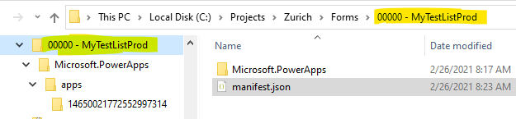

1. Navigate to the manifest JSON file in the root folder of the unzipped structure. See prior image.
2. Edit the manifest file and set the display name of the app

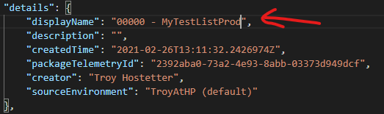

1. Set the display name on the details of the resource

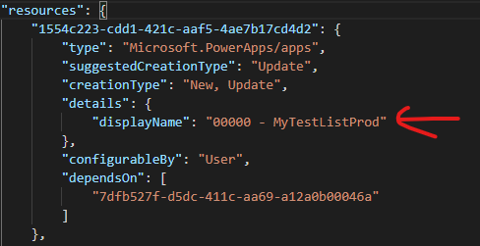

1. Save the changes to the manifest JSON file
2. Navigate to the JSON file in the /Microsoft.PowerApps/apps/#### folder

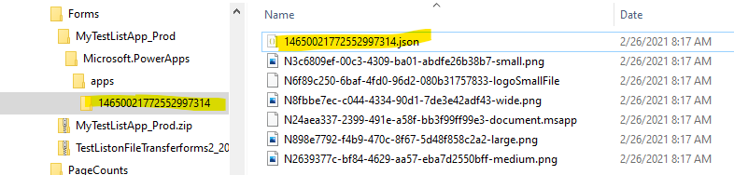

1. Edit in vs.code .. hit Shift+Alt+F to format the file
2. Update the app name to the proper Production name

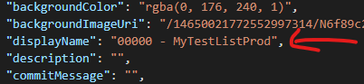

1. Change the ListId to the Id captured in Step 1. Change the listUrl to the target listUrl. The listUrl is the path to the target list AllItems.aspx page.

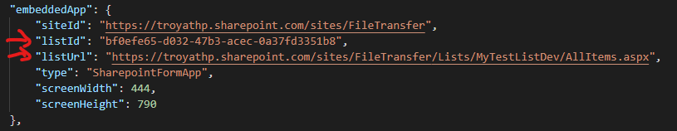

1. Save the changes to the JSON file
2. Navigate to the root folder, select the folder and manifest, right-click and zip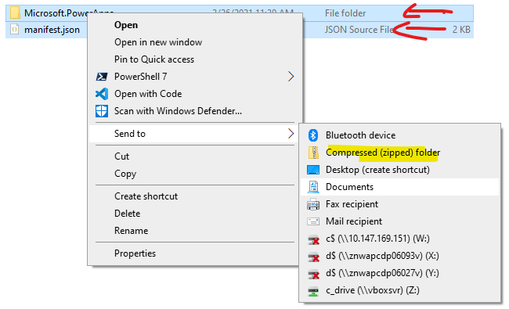
3. Rename the new Zip file <SiteId>-<SiteName>.zip

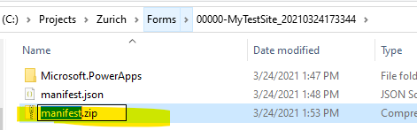

1. In Power Apps, import the zip file

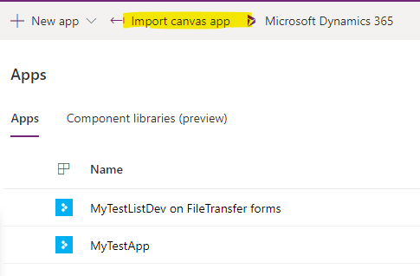

1. Select Upload and browse to the zip file, if you did EVERYTHING correctly on the FIRST try .. good for you! You should see the following image, otherwise a Red bar will appear stating there were problems. Note .. it does not tell you what the problem is, so it’s likely you’ll need to review everything you did.

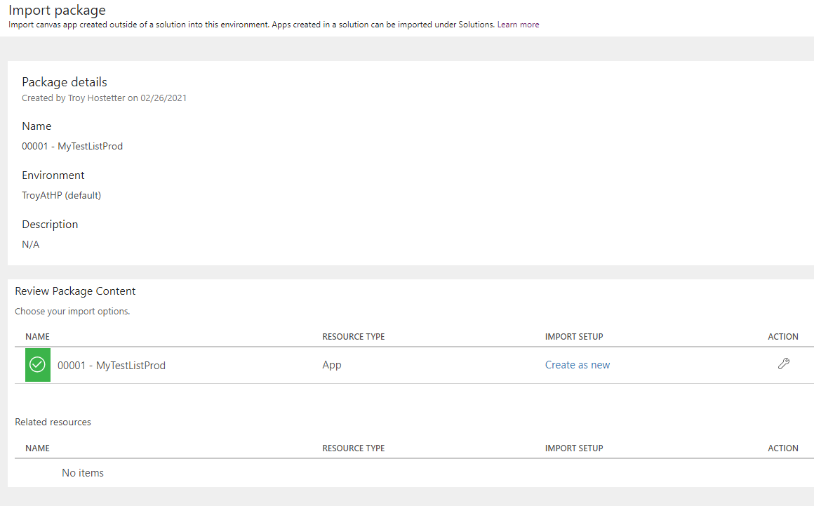

1. A final message states your package was successfully imported.

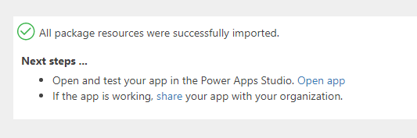

1. Select Open app to open the imported app in Power Apps
   1. If the following message appears, the JSON edits were done incorrectly.

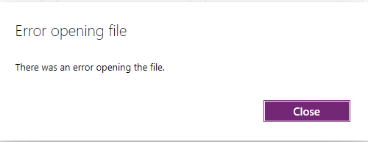

* 1. If you receive the above error, you must delete the app from the list and try again. To do so, go to list settings, and then Form Settings, and select Delete custom form

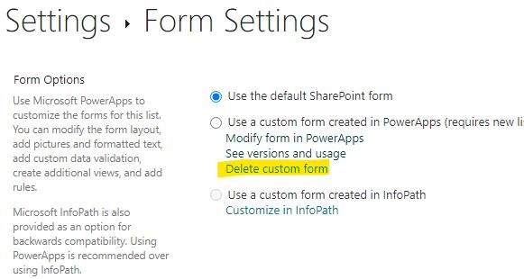

1. However, if everything went properly, when you select Open App, you will be taken to the Power App editor for the new App pointing to the new List.
2. At this point the data connection is still pointing to the old list. First, remove the data connection. Select the database icon.

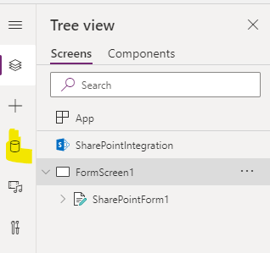

1. Select Remove, then select Add Data

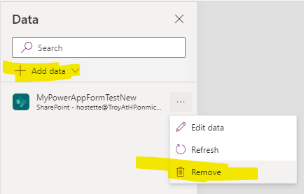

1. Then select SharePoint from the list of connectors.

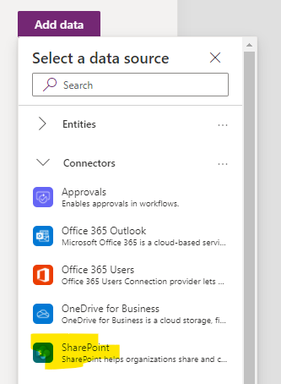

1. Once SharePoint is selected, a list of available sites appears on the right.

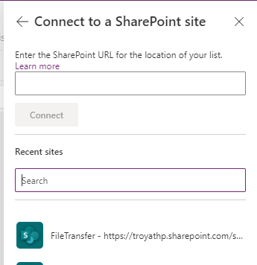

1. Select the site with the list, then select the list you want to connect the form to.

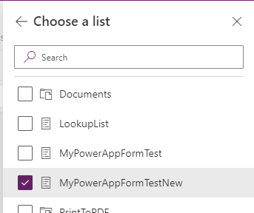

1. One you do this, your form data fields are still not connected to the new list. You’ll have a form with some red errors on it.

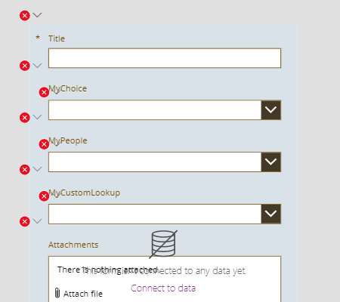

1. From here, you MUST select the form itself. This is typically “SharePointForm1” if you never renamed it. Upon selecting the form, you should a Data source selection of None. Select the an empty

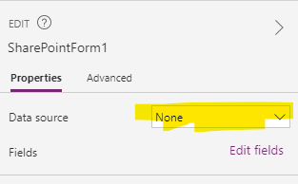

1. Select the connection that you created in steps 29-31.

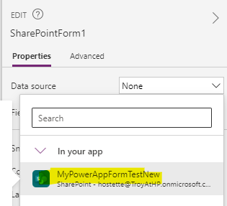

1. You will then be presented with this window. Select Select No thanks as you will need to update all of the data cards with the proper connection.

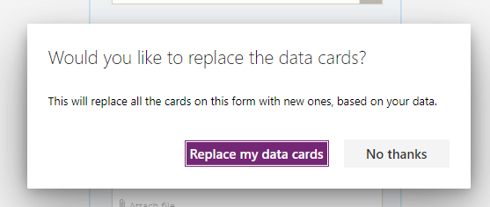

1. All of your data fields should now be pointing to the new list. You may need one final update. If you notice a red error message on the form, you will need to update the formula for the form.

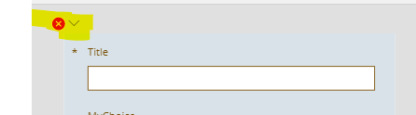

1. Replace the old list name with the new list name.

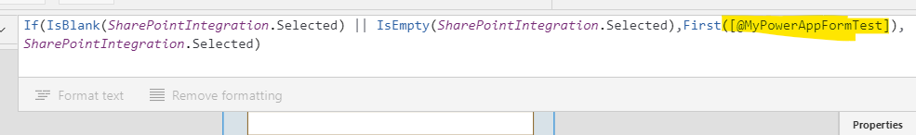

1. A warning Icon will appear, but you can ignore it.

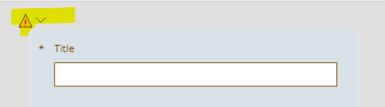

1. Select File then Save.

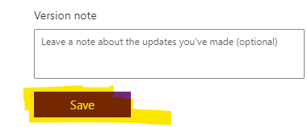

1. Select Publish. Note .. the initial publish may take a few minutes, so please be patient.

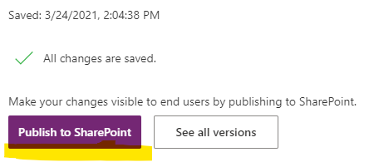

1. Now go to the SharePoint list and select New, and the new form will appear.